

**Egypt's International Furniture and Furnishings Trade Fair**

**21st – 24th February 2019**

**Cairo International Convention and Exhibition Center**

**List of Recommended International Visitors )For Exhibitors Only )**

**Exhibitors' Contact Information**

|  |
| --- |
| **\* Company Name _______________________________________________________________________________________**  **\*Sector ______________________________________*Hall _____________________________________________________**  **\*Contact Person: (Mr. /Ms. /Mrs.) * Name __________________________________________________________________**  **\* Title ( Position Held in Company ) ________________________________________________________________________**  **\* Address ___________________________________________________________________* City ______________________**  **\* Telephone_________________________ Fax. _______________________________* Mobile __________________________**  **\* Company E-mail: ______________________________________________________________________________________**  **\* Personal E-mail:_______________________________________________________________________________________**  **\*Website : ____________________________________________________________________________________________** |

**Visiting Companies List:**

|  |  |  |  |  |  |  |  |  |
| --- | --- | --- | --- | --- | --- | --- | --- | --- |
| No | Company Name | Country | Visitor Name | Nationality | Telephone | Mobile | Email | Website |
| 1 |  |  |  |  |  |  |  |  |
| 2 |  |  |  |  |  |  |  |  |
| 3 |  |  |  |  |  |  |  |  |
| 4 |  |  |  |  |  |  |  |  |
| 5 |  |  |  |  |  |  |  |  |

Notes:

* All recommendations are subject to the final approval of Furnex & The Home management committee
* The International Visitors Program (IVP) program will include:
* 3 nights free accommodation in 5 stars hotel on B&B basis
* Round trip flight ticket to and from Cairo airport
* Free Meet & Assist service at airport and transfer between airport-hotel-airport
* Free shuttle services between hotel-exhibition-hotel
* Free Welcome Kit (including fair booklet)
* Access to the International Buyers Lounge
* Should there be any additional visitor/s from the same visiting company; the exhibitor must cover all related expenses of their visit.

|  |
| --- |
| Please return back to EFEC  **Tel.:** +2 02 2528 5037- +2 02 2528 5036 **Fax:** +2 02 2528 5036 (ext.: 111)  **Contact Person:** Reem Essam, Projects Coordinator  **Email:** [ressam@efec.org.eg](mailto:ressam@efec.org.eg); [furnexthehome@efec.org.eg](mailto:furnexthehome@efec.org.eg) |

**For more details, please visit** [**www.furnexthehome.com**](http://www.furnexthehome.com)

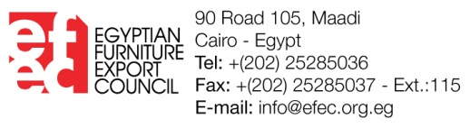

**Organized by**